**Putty Installation:**

**Step 1**

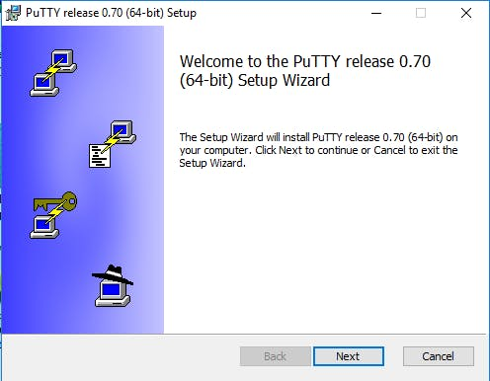

**Step 2**

**Step 3**

**Step 4**

Now this is the dialog box you’ll see when you open putty for the first time:

Now the next step is in two-fold, first click on red colour Pi icon which is at the top leftmost corner of the monitor and then click on preferences and then click on Raspberry Pi configuration.

Then go to interfaces block and click on enabled SSH and press ok then reboot your Pi. This can be seen in the snapshot below:

Once you reboot your Pi, now it’s time to know your Pi IP address which can be found by sudo ifconfig command then if you are using a LAN connection straight away look at inet addr under lan0 and if you are using wireless connection like me straight away look on inet addr under wlan0 and just write down the IP address somewhere we gonna need it in future.

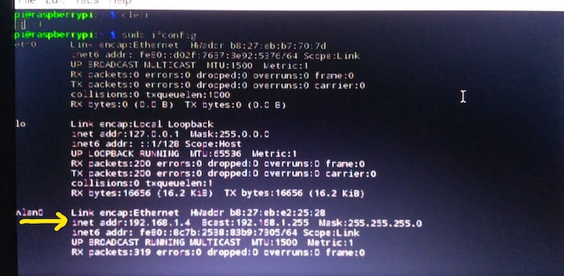

Now ,you have come to the penultimate step of this whole exercise of connecting you Pi with your laptop or desktop.

So therefore click on the Putty icon, click on the saved session in my case I gave it a name as “rasp1” then click on load, once you click on the name of your saved session the IP address will appear automatically under the Host name bar and then click on open, it will ask you your username and password and once you give it you are good to go and then you can freely use your pi without any keyboard, mouse or any connector.

Let me show through this snapshot what all I mentioned above:

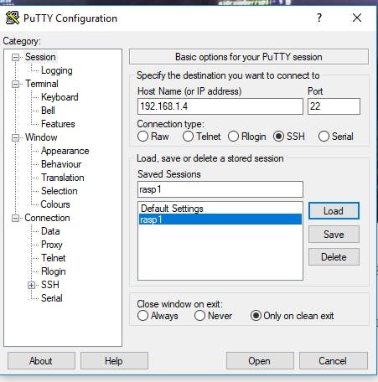

Putty you only require your laptop and Raspberry Pi. Here you can see my Raspberry Pi 3 is connected to my laptop using Putty and you can see me to at my laptop screen.

